ADITYA UNIVERSITY

SCHOOL OF COMPUTING

DEPARTMENT OF COMPUTER APPLICATIONS

PROJECT REPORT ON IoT-Based Smart Water Leakage Alert System
Submitted in partial fulfilment of the requirements for the award of the degree of
Master of Computer Applications (MCA).
Submitted by:
1.A. GIRIJA KUMARI— [25M11MC005]
2.G.UMA SRI — [25M11MC038]
3.M. NAGA DURGA — [25M11MC091]
4.V.V.V.G. BHAVANI — [25M11MC158]
Under the Guidance of
Prof. Dr. Rajamohan Parthasarathy
Professor, Department of Computer Applications,
School of Computing, Aditya University
&
Ms. U. N. Ratna kumari / Mr. K. S. Sai Kishore
Assistant Professor, Department of Computer Applications,
School of Computing, Aditya University
Year: June 2026- Nov 2026 & Semester: III

CERTIFICATE
This is to certify that the project report entitled “[IoT-Based Smart Water Leakage Alert System]” is a bonafide record of the work carried out by [A.Girija kumari , G.Uma sri , M.Naga durga ,V.V.V.G.Bhavani], bearing roll number(s) [25M11MC005, 25M11MC038, 25M11MC091, 25M11MC158], in partial fulfilment of the requirements for the award of the degree of [Master Of Computer Applications] at [Aditya University] during the academic year June 2026 – Nov 2027. The project work was completed under my guidance and supervision. To the best of my knowledge, the work presented in this report is original and has fulfilled the academic requirements of the institution.

Project Guide:
Name: ____________________

Signature: ________________
&
Name: ____________________
Signature: ________________

Head of the Department:
Name: ____________________
Signature: ________________

Date:
Place:

DECLARATION
We hereby declare that the project entitled “[Project Title]” is the record of our original work carried out under the guidance of [Guide Name] at [Institution Name].
We further declare that this report has not been submitted, either in full or in part, to any other institution or university for the award of any degree or diploma.
Student Name(s) and Signature(s):

Date: __________
Place: __________

ACKNOWLEDGEMENT

We express our sincere gratitude to the management of [Aditya University] for providing the necessary facilities and support to complete this IoT project successfully.

We thank the Head of the Department, [Name], for the encouragement and guidance provided throughout the project.

We extend our heartfelt thanks to our project guide, [Guide Name and Designation], for valuable suggestions, technical guidance, and continuous support during the design, development, and testing phases.

We also thank the faculty members, laboratory staff, team members, and our families for their cooperation and encouragement.

Finally, we acknowledge the resources and tools that helped us implement and test the proposed IoT system.

ABSTRACT

The Internet of Things (IoT) enables physical devices to collect, process, and exchange data through network connectivity. This project, entitled “Smart water leakage alert system,” aims to develop an IoT-based solution to address “leakage problem”. The proposed system consists of YFS-201 sensor, Arduino Uno, communication technology, and a future mobile platform. The sensors collect real-time information, which is processed by the Arduino uno and transmitted to the monitoring platform. Based on the collected data, the system provides monitoring, alerts, automation, analytics, or control. The project was implemented using [Arduino-uno,YFS-201sensor,LED,Buzzer,Resistor,Breadboard , [Arduinoprogramming language], and [Tinkered ai]. The completed system was tested under different operating conditions to evaluate its functionality, accuracy, response time, and reliability. The results demonstrate that the developed prototype can [summarize the verified outcome]. The project offers a practical approach to improving [efficiency, safety, resource management, or monitoring] and can be enhanced through additional sensors, data analytics, and advanced IoT technologies.

Keywords: Internet of Things, sensors, microcontroller, real-time monitoring, wireless communication, automation.

TABLE OF CONTENTS
- Introduction
- Literature Review
- System Analysis and Design
- Hardware and Software Requirements
- Implementation and Integration
- Testing and Results
- Conclusion and Future Enhancements
- References
- Appendices

CHAPTER 1: INTRODUCTION
  - Introduction to IoT
The Internet of Things (IoT) is a concept in which physical devices use sensors, controllers, and communication technologies to collect and exchange data. An IoT system commonly includes a sensing layer, a processing layer, a communication layer, and an application layer. IoT is used in smart homes, agriculture, healthcare, industrial monitoring, and resource management. In this project, the sensing and processing stages are implemented using a YF-S201 water flow sensor and an Arduino Uno. The current prototype generates local alerts through an LED and buzzer. Network communication and remote monitoring are planned for a future version.
  - Background of the Project
Water leakage in homes and buildings can waste water and may cause property damage when it remains unnoticed. Manual inspection depends on a person noticing visible water or unusual usage, so hidden or continuous leakage may not be detected immediately. The proposed project monitors water flow in a pipe and uses a controller to identify flow above a configured threshold. It is intended as a low-cost prototype demonstrating sensor-based monitoring and local alert generation.

1.3 Problem Statement
The problem addressed by this project is the delayed identification of abnormal water flow that may indicate a leak. Manual observation does not continuously measure flow, and a leak may continue until a person notices it. A compact sensor-and-controller system is therefore proposed to monitor flow and activate an alert when the measured flow crosses a predefined threshold. A single flow sensor can indicate abnormal flow but cannot identify the exact location of a leak.

1.4 Objectives
- To monitor water flow through a pipeline using a YF-S201 sensor.
- To process the sensor pulse signal using an Arduino Uno.
- To calculate flow rate using a configured calibration factor.
- To compare measured flow with a predefined threshold.
- To activate an LED, buzzer, and LCD status message when the threshold condition is met.
- To verify the circuit and basic program logic in simulation and identify future improvements.

1.5 Scope of the Project
The project scope includes flow measurement, pulse counting, threshold-based abnormal-flow detection, and local alerts using an LED and buzzer. The LCD displays the measured flow rate and status. The present prototype is intended for demonstrating the concept on a monitored pipeline. Wi-Fi/cloud connectivity, mobile notifications, multi-point leak localization, and large-scale building deployment are outside the completed scope and may be considered as future enhancements.

1.6 Existing System
In a conventional approach, leakage may be noticed through visual inspection, damp areas, or unexpectedly highwater usage. Such methods do not continuously measure flow and may delay detection. They may also require manual inspection of multiple locations. The proposed sensor-based approach continuously measures flow at the sensor location and provides an immediate local indication when the configured threshold is exceeded.

1.7 Proposed System
The proposed system connects a YF-S201 water flow sensor to an Arduino Uno. The sensor generates pulses as water passes through its internal turbine. The Arduino counts the pulses, calculates flow rate, and compares it with a configured threshold. If the threshold is exceeded, the LCD displays “ALARM”, the LED turns on, and the buzzer sounds intermittently. Otherwise, the display shows “NORMAL” and the alerts remain off. Remote IoT notifications are planned but are not part of the current local-alert implementation.

1.8 Organization of the Report
Chapter 1 introduces the project and its objectives. Chapter 2 outlines the literature-review themes and the research gap to be supported with verified references. Chapter 3 describes the system architecture, working principle, and algorithm. Chapter 4 lists the hardware and software requirements. Chapter 5 explains implementation and integration. Chapter 6 provides a testing plan and a place to record actual results. Chapter 7 summarizes the project, limitations, and future enhancements. References and appendices provide technical sources, source code, wiring details, and evidence.

CHAPTER 2: LITERATURE REVIEW

2.1 Introduction
A literature review helps establish how existing water-monitoring and leakage-detection systems use sensors, microcontrollers, communication networks, and alert mechanisms. It also helps identify limitations that a student prototype can address. The review below describes relevant technology categories; verified research-paper details should be added before final submission rather than attributing unverified findings to specific authors.

2.2 Review of Existing Studies
Relevant literature to be reviewed for this project includes the following areas:
- Research on flow-sensor-based water monitoring systems.
- Technical documentation for the YF-S201 water flow sensor and its pulse-output characteristics.
- Arduino-based embedded monitoring and threshold-triggered alert systems.
- IoT water-monitoring systems that transmit sensor readings to cloud dashboards or mobile applications.
- For final submission, add verified authors, publication years, exact titles, methods, findings, and limitations from the papers or official documentation actually consulted.

2.3 Comparison of Existing Systems
A simple flow-monitoring prototype can use a flow sensor and a microcontroller to trigger local alerts. More advanced systems may add Wi-Fi, cloud dashboards, mobile notifications, data logging, and multiple sensors. The current project uses a YF-S201 sensor, Arduino Uno, LCD, LED, and buzzer for local measurement and alerts. Since no verified comparison papers were supplied in the Review-I document, a formal literature comparison table should be completed using actual sources before submission.

2.4 Research Gap
The project focuses on a low-cost, understandable prototype that measures flow and triggers a local alarm when a configured threshold is crossed. Its current limitation is that a single sensor cannot identify the exact leak location, and the threshold method may confuse normal high flow with leakage. Adding duration-based rules, calibrated thresholds, multiple sensors, and remote monitoring may improve the system. These are design considerations, not claims that all improvements have already been implemented.

2.5 Summary
The reviewed technology areas support the feasibility of sensor-based flow monitoring. For academic completeness, this chapter should be supplemented with verified papers and official technical references, including source details and access dates where required by the university.

CHAPTER 3: SYSTEM ANALYSIS AND DESIGN

3.1 System Architecture
System architecture: Water pipeline → YF-S201 flow sensor → Arduino Uno → flow-rate calculation and threshold check → LCD status display plus LED/buzzer local alert. A Wi-Fi/cloud/mobile notification path is proposed for a future version only.

3.2 Block Diagram
Sensors → Arduino Uno → Communication Network → Cloud/IoT Platform → User Dashboard/Alerts.

The system consists of five main blocks: (1) the YF-S201 sensor measures flow and produces pulses; (2) the Arduino Uno counts pulses and processes the data; (3) leakage-detection logic compares the calculated flow with a configured threshold; (4) the LCD displays flow rate and status; and (5) the LED and buzzer provide local alerts when the threshold condition is met.

3.3 Working Principle
1. Water Flow Detection
When water passes through the YF-S201 sensor, its internal turbine rotates, and the Hall-effect sensing element generates pulses.
2. Pulse Counting
The Arduino counts these pulses using an interrupt.
3. Flow Rate Calculation
At each measurement interval, the program copies and resets the pulse counter, then calculates the flow rate using the configured calibration factor.
4. Threshold Comparison
The calculated flow rate is compared with the predefined LEAK_THRESHOLD_LPM.
5. Output and Alert System
- If the flow rate exceeds the threshold (ALARM):
- The LCD displays “ALARM”.
- The LED turns ON.
- The buzzer alternates between sound and silence.
- If the flow rate does not exceed the threshold (NORMAL):
- The LCD displays “NORMAL”.
- The LED and buzzer remain OFF.
Note: The threshold-based method identifies abnormal water flow; it does not, by itself, confirm that a leak exists.

3.4 Functional Requirements
- Read pulse signals from the YF-S201 sensor.
- Count pulses and calculate the flow rate at a fixed interval.
- Display the calculated flow rate and status on the LCD.
- Compare the measured flow rate with the configured threshold.
- Activate the LED and buzzer when the threshold is exceeded.
- Provide a serial output for debugging and testing; cloud storage and visualization are future work.

3.5 Non-Functional Requirements
- The system should operate consistently during continuous monitoring.
- The pulse-counting and alert logic should respond within the configured measurement and buzzer intervals.
- Any future network implementation should protect credentials and user data.
- The design can be extended with additional sensors or a Wi-Fi-capable controller.
- The LCD and local indicators should make the system status easy to understand.
- The modular code and wiring should be easy to inspect, calibrate, and maintain.

3.6 System Flowchart
System flow: Start → initialize sensor, LCD, LED, and buzzer → count flow pulses → calculate flow rate each measurement interval → compare with threshold → if exceeded, show ALARM and activate LED/buzzer; otherwise show NORMAL and keep alerts off → repeat monitoring until power is switched off.

3.7 Algorithm
- Start the system.
- Initialize the sensor, LCD, LED, and buzzer.
- Count sensor pulses using an interrupt.
- Calculate the flow rate.
- Compare the flow rate with the threshold.
- Display the flow rate and status on the LCD.
- If the threshold is exceeded, turn ON the LED and buzzer; otherwise, keep them OFF.
- Repeat monitoring until the system is switched off.

3.8 Use-Case Diagram
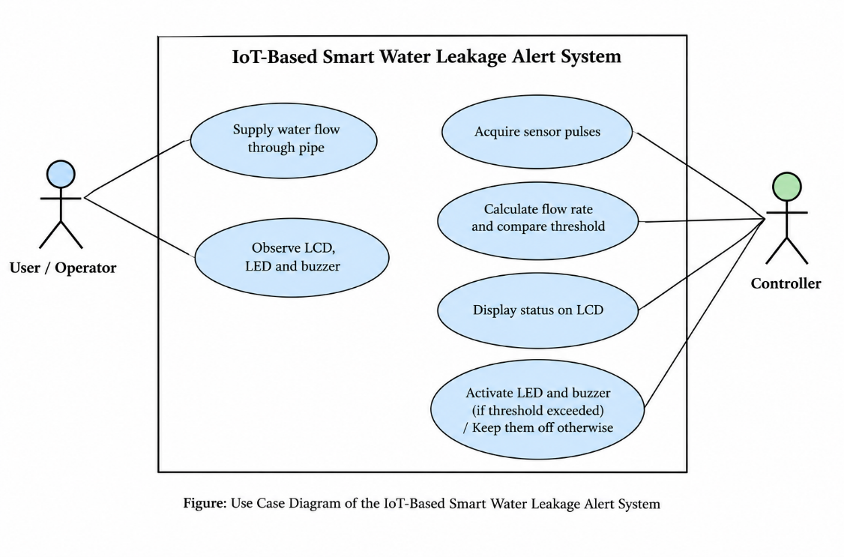

CHAPTER 4: HARDWARE AND SOFTWARE REQUIREMENTS

4.1 Hardware Components
Hardware components used or specified in the current prototype:

S. No. | Component | Specification | Purpose
1 | Microcontroller | Arduino Uno | Processes sensor pulses and controls outputs
2 | Water flow sensor | YF-S201 | Measures flow and generates pulse output
3 | Display | 16×2 LCD | Displays flow rate and system status
4 | Alert devices | LED, buzzer, 220Ω resistor | Provides local visual and audio alerts
5 | Prototyping | Breadboard and jumper wires | Circuit assembly and connections
6 | Power/programming | USB cable and suitable power supply | Powers/programs the controller

4.2 Software Requirements
Software/Tool | Version | Purpose
Arduino IDE | Your installed version | Writing and uploading the program
Arduino C/C++ | As supported by Arduino IDE | Controlling the sensor, calculating flow rate, and generating alerts
IoT Platform | Not applicable currently | No cloud platform is implemented
Database | Not applicable currently | No database is implemented
Mobile/Web Application | Not applicable currently | No mobile or web application is implemented

4.3 Circuit Diagram
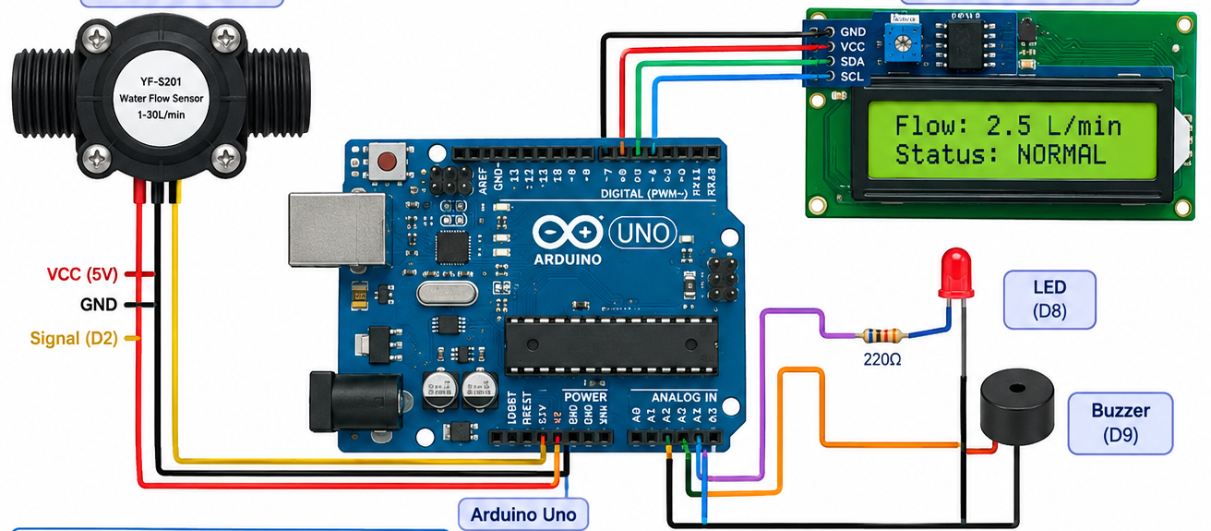

4.4 Pin Configuration
- Digital Pin 2: Receives pulse signals from the YF-S201 flow sensor.
- Digital Pin 8: Controls the blue LED to indicate normal flow.
- Digital Pin 9: Controls the red LED to indicate a leakage alert.
- Digital Pin 10: Controls the buzzer to produce an alert sound.
- 5V and GND: Provide power to the flow sensor and complete the circuit.

4.5 Communication Protocol
The current implementation uses a pulse signal from the YF-S201 water flow sensor to communicate with the Arduino and I²C communication for the 16×2 LCD. Wi-Fi, MQTT, HTTP, or cloud communication is not implemented in the current code. For future remote notifications, a Wi-Fi-capable board or communication module and a suitable IoT platform would be required.

CHAPTER 5: IMPLEMENTATION AND INTEGRATION

5.1 Development Environment

The project was developed using an Arduino-compatible programming environment and an online circuit simulator. The program uses an interrupt-driven pulse counter, timing based on millis(), an LCD library, and local LED/buzzer outputs. The Review-I material records circuit design, sensor integration, basic Arduino programming, leakage-detection logic, and simulation as completed. Physical hardware assembly should be documented with photographs and wiring details only after the actual components are assembled and tested.

5.2 Hardware Implementation

The software is organized into setup() and loop(). setup() initializes serial communication, configures input/output pins, attaches the pulse interrupt, starts I2C and the LCD, and displays the initial NORMAL status. loop() periodically reads and resets the pulse count, calculates flow rate, compares it with the threshold, updates the LCD, and controls the LED and buzzer.

5.3 Software Implementation

The sensor output is connected to FLOW_PIN. Each rising edge triggers onFlowPulse(), which increments the volatile pulse counter. At each measurement interval, the program briefly disables interrupts to copy and reset the counter safely, then re-enables interrupts. This prevents the main loop from reading the counter while it is being changed by the interrupt routine.

5.4 Sensor Data Acquisition
The YF-S201 flow sensor sends pulse signals to Arduino Uno through Digital Pin 2. The Arduino counts these pulses every second and calculates the water flow rate.
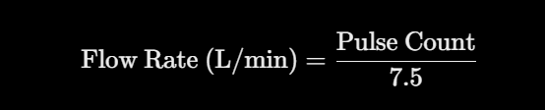
The calculated flow rate is compared with the threshold of 0.5 L/min. If it exceeds the threshold, the red LED and buzzer turn ON. Otherwise, the blue LED remains ON, indicating normal flow.

5.5 Data Processing

Remote IoT connectivity is planned for future development but is not implemented in the current system. The current program does not send data to any cloud platform or mobile application. In the future, ESP8266 or ESP32 can be used with platforms such as ThingSpeak or Blynk for remote monitoring and notifications.

5.6 IoT Connectivity

The current system uses a Yellow LED, red LED, and buzzer for local alerts. The blue LED indicates normal flow, while the red LED and buzzer indicate a flow rate above the threshold. Remote IoT connectivity and mobile notifications are planned for future development but are not implemented in the current version.

5.7 Dashboard and Alert Implementation

Implementation and Circuit Status
The sensor, Arduino controller, LCD, LED, and buzzer are planned to be integrated through the circuit wiring and Arduino program. The YF-S201 water flow sensor provides pulse data to the Arduino, which calculates the flow and determines whether the flow is normal or abnormal. The LCD displays the flow status, while the LED and buzzer provide local alerts when abnormal flow is detected. The Review-I report indicates that the circuit simulation was completed. Screenshots of the circuit simulation and LCD output can be included as supporting evidence in the Review-II report.

5.8 Integration
The proposed system integrates the YF-S201 water flow sensor, Arduino Uno, 16×2 I²C LCD, LED, and buzzer. The YF-S201 provides pulse signals to the Arduino, and the embedded program processes the sensor data to determine whether the water flow is normal or abnormal. The LCD displays the system status, while the LED and buzzer provide a local alert when abnormal flow is detected.
At the current stage, the project has been tested through simulation. The Review-I simulation screenshots can be included as evidence and should be labelled as simulation results. The physical prototype, network/IoT communication, and remote user interface are planned for the later implementation stage and should not be presented as completed.

5.9 Completed Project Photographs

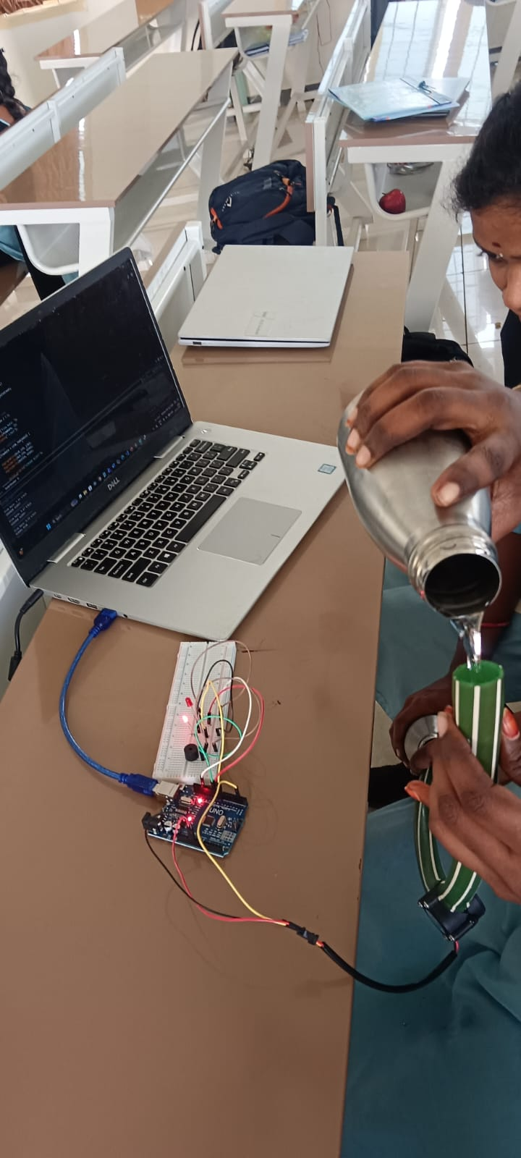

5.10 Source Code

// Smart Water Leakage Alert System

// Pin connections

const int FLOW_SENSOR = 2;

const int BLUE_LED = 8;

const int RED_LED = 9;

const int BUZZER = 10;

// Flow sensor pulse counter

volatile unsigned long pulseCount = 0;

float flowRate = 0.0;

// Leakage threshold

const float LEAK_THRESHOLD = 0.5;

unsigned long previousMillis = 0;

// Count sensor pulses

void countPulse() {

pulseCount++;

}

void setup() {

Serial.begin(9600);

pinMode(FLOW_SENSOR, INPUT_PULLUP);

pinMode(BLUE_LED, OUTPUT);

pinMode(RED_LED, OUTPUT);

pinMode(BUZZER, OUTPUT);

attachInterrupt(

digitalPinToInterrupt(FLOW_SENSOR),

countPulse,

FALLING

);

// Initial condition

digitalWrite(BLUE_LED, HIGH);

digitalWrite(RED_LED, LOW);

digitalWrite(BUZZER, LOW);

Serial.println("Smart Water Leakage Alert System");

Serial.println("System Started");

}

void loop() {

if (millis() - previousMillis >= 1000) {

previousMillis = millis();

// Read sensor pulses

noInterrupts();

unsigned long pulses = pulseCount;

pulseCount = 0;

interrupts();

// Calculate flow rate

flowRate = pulses / 7.5;

Serial.print("Flow Rate: ");

Serial.print(flowRate, 2);

Serial.println(" L/min");

// Leakage condition

if (flowRate > LEAK_THRESHOLD) {

digitalWrite(BLUE_LED, LOW);

digitalWrite(RED_LED, HIGH);

digitalWrite(BUZZER, HIGH);

Serial.println("LEAKAGE ALERT!");

} else {

digitalWrite(BLUE_LED, HIGH);

digitalWrite(RED_LED, LOW);

digitalWrite(BUZZER, LOW);

Serial.println("NORMAL FLOW");

}

Serial.println("-------------------");

}

}

CHAPTER 6: TESTING AND RESULTS

6.1 Testing Methodology
Testing should include power-on initialization, pulse counting, flow-rate calculation, LCD updates, threshold behaviour, LED operation, and buzzer operation. Test with normal flow and a range of controlled flow conditions. Record actual values, calibration method, and observations. The Review-I report confirms simulation completion but does not provide measured experimental results.

6.2 Functional Test Cases
Test ID | Test Scenario | Expected Result | Actual Result | Status
TC01 | Power-on initialization | Arduino and LCD initialize; initial status appears | Record after test | Pending
TC02 | Sensor pulse input | Pulse counter increases when flow passes sensor | Record after test | Pending
TC03 | Flow calculation | Displayed flow is calculated using configured factor | Record measured value | Pending
TC04 | Below-threshold flow | LCD shows NORMAL; LED and buzzer remain off | Record after test | Pending
TC05 | Above-threshold flow | LCD shows ALARM; LED and buzzer activate | Record after test | Pending
TC06 | Alarm reset condition | When flow falls below threshold, alarm outputs turn off | Record after test | Pending

6.3 Experimental Results
The system has been tested at the current stage using Arduino and the connected components. The YF-S201 sensor provides pulse data to the Arduino, which calculates the flow rate. The blue LED indicates normal flow, while the red LED and buzzer activate when the flow exceeds the threshold.
Detailed numerical readings, calibration, and accuracy measurements will be recorded after further physical testing.

6.4 Performance Evaluation

The simulation shows that the YF-S201 sensor sends flow data to the Arduino, which checks whether the flow is normal or abnormal. The LCD displays the status, and the LED and buzzer provide an alert when abnormal flow is detected. At this stage, Wi-Fi, cloud communication, and remote alerts are not implemented. Physical testing is still required to check the sensor accuracy, response time, reliability, and power consumption. The main limitations are the single sensor, selected flow threshold, calibration, and lack of network connectivity. The simulated system follows the intended process of sensing, processing, displaying the status, and giving a local alert.

6.5 Result Analysis

The system demonstrates basic water flow monitoring using the YF-S201 sensor and Arduino Uno. The Arduino calculates the flow rate and compares it with the threshold. The blue LED indicates normal flow, while the red LED and buzzer provide alerts when the flow exceeds the threshold. Further physical testing is required to verify system reliability.

6.6 Output Screenshots
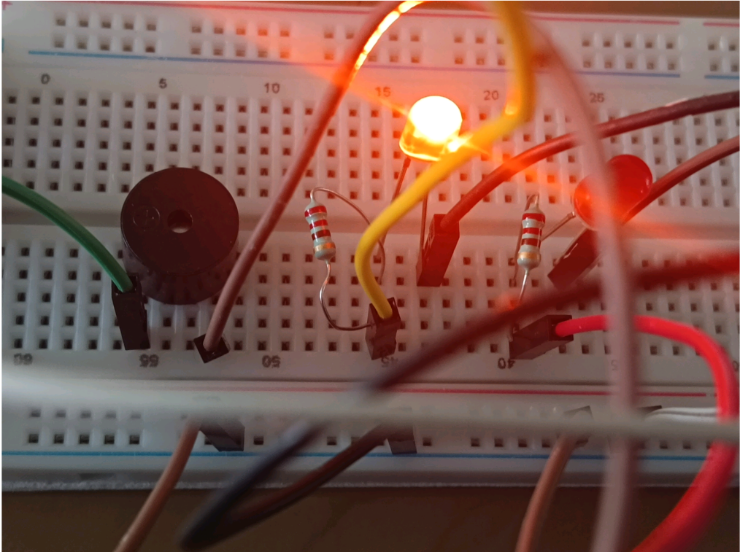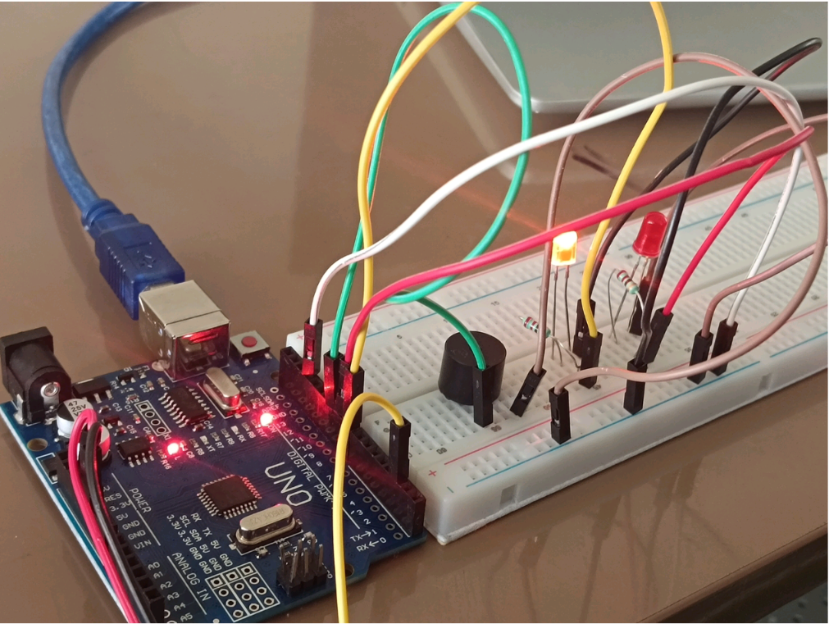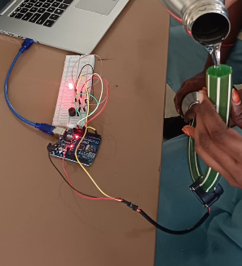

6.7 Discussion

The system monitors water flow using the YF-S201 sensor and Arduino Uno. It provides local alerts through the LEDs and buzzer when the flow exceeds the threshold. Further physical testing is required to evaluate the accuracy and reliability of the system

CHAPTER 7: CONCLUSION AND FUTURE ENHANCEMENTS

7.1 Conclusion

The Smart Water Leakage Alert System uses a YF-S201 water flow sensor and Arduino Uno to monitor water flow. The blue LED indicates normal flow, while the red LED and buzzer provide an alert when the flow exceeds the set threshold. The basic circuit and program have been prepared. Physical testing, calibration, and IoT connectivity are planned for the next stage.

7.2 Objectives Achieved
• Designed the basic system circuit using Arduino Uno.
• Integrated the YF-S201 water flow sensor.
• Implemented pulse counting and flow-rate calculation.
• Programmed LED and buzzer alerts based on the flow threshold.
• Prepared the system for physical testing.

7.3 Limitations
• A single sensor cannot identify the exact leakage location.
• Sensor accuracy depends on calibration.
• The system uses a fixed flow threshold.
• Only local alerts are available.
• IoT connectivity is not implemented.

7.4 Future Enhancements
• Add Wi-Fi connectivity using ESP8266 or ESP32.
• Develop a mobile or web dashboard.
• Add multiple sensors to identify leakage locations.
• Improve calibration and alert logic.
• Explore AI/ML-based water-flow anomaly detection.

REFERENCES
List all books, journal articles, conference papers, official documentation, and technical resources cited in the report.
Use the referencing style required by your institution, such as IEEE or APA. For example:
- Author(s), “Title of the research paper,” Journal Name, vol. X, no. X, pp. XX–XX, Year.
- Author(s), “Title of the conference paper,” in Proceedings of Conference Name, Year, pp. XX–XX.
- Arduino, “Arduino Documentation.” [Insert the official URL and access date if required.]
- [IoT platform documentation, sensor datasheet, and relevant technical manuals.]
Verify all author names, titles, publication details, DOI information, and URLs before submission.

APPENDIX A: SOURCE CODE
Arduino Source Code:
The following Arduino program is used to monitor water flow using the YF-S201 water flow sensor. It calculates the water flow rate and compares it with the predefined threshold of 0.5 L/min. Based on the readings, the system activates the blue LED during normal flow and the red LED with a buzzer when the flow rate exceeds the threshold. The flow readings and system status are displayed through the Serial Monitor.
Code:
/*
Smart Water Leakage Alert System
*/

// Pin connections
const int FLOW_SENSOR = 2;
const int BLUE_LED = 8;
const int RED_LED = 9;
const int BUZZER = 10;

// Flow sensor pulse counter
volatile unsigned long pulseCount = 0;

float flowRate = 0.0;

// Leakage threshold
const float LEAK_THRESHOLD = 0.5;

unsigned long previousMillis = 0;

// Count sensor pulses
void countPulse() {
pulseCount++;
}

void setup() {
Serial.begin(9600);

pinMode(FLOW_SENSOR, INPUT_PULLUP);
pinMode(BLUE_LED, OUTPUT);
pinMode(RED_LED, OUTPUT);
pinMode(BUZZER, OUTPUT);
attachInterrupt(
digitalPinToInterrupt(FLOW_SENSOR),
countPulse,
FALLING
);

// Initial condition
digitalWrite(BLUE_LED, HIGH);
digitalWrite(RED_LED, LOW);
digitalWrite(BUZZER, LOW);

Serial.println("Smart Water Leakage Alert System");
Serial.println("System Started");
}

void loop() {

if (millis() - previousMillis >= 1000) {

previousMillis = millis();

// Read sensor pulses
noInterrupts();
unsigned long pulses = pulseCount;
pulseCount = 0;
interrupts();

// Calculate flow rate
flowRate = pulses / 7.5;

Serial.print("Flow Rate: ");
Serial.print(flowRate, 2);
Serial.println(" L/min");

// Leakage condition
if (flowRate > LEAK_THRESHOLD) {

digitalWrite(BLUE_LED, LOW);
digitalWrite(RED_LED, HIGH);
digitalWrite(BUZZER, HIGH);

Serial.println("LEAKAGE ALERT!");

} else {

digitalWrite(BLUE_LED, HIGH);
digitalWrite(RED_LED, LOW);
digitalWrite(BUZZER, LOW);

Serial.println("NORMAL FLOW");
}

Serial.println("-------------------");
}
}

APPENDIX B: ADDITIONAL CIRCUIT DIAGRAMS
The circuit diagram shows the connections between Arduino Uno, YF-S201 water flow sensor, blue LED, red LED, and buzzer.
Pin Configuration:
Component | Pin
Flow Sensor Signal | D2
Blue LED | D8
Red LED | D9
Buzzer | D10
Sensor VCC | 5V
Sensor GND | GND
The Arduino Uno receives water flow signals from the sensor and controls the LEDs and buzzer based on the flow rate.

APPENDIX C: ADDITIONAL TEST RESULTS
The system was tested under different water flow conditions to verify the sensor readings and alert functions.
Testing Results:
Test | Expected Result
Normal water flow | Blue LED ON
Flow above 0.5 L/min | Red LED and buzzer ON
Sensor pulse detection | Flow rate displayed
LED testing | LEDs operate correctly
Buzzer testing | Audible alert

APPENDIX D: USER MANUAL
Steps to Operate the System:
- Connect the YF-S201 water flow sensor to the Arduino Uno.
- Connect the blue LED, red LED, and buzzer to their respective pins.
- Connect the Arduino Uno to the computer using a USB cable.
- Open Arduino IDE and upload the program.
- Open the Serial Monitor and select 9600 baud.
- Observe the water flow readings.
- If the flow rate exceeds 0.5 L/min, the red LED and buzzer are activated.
- If the flow rate is within the threshold, the blue LED indicates normal flow.
Troubleshooting:
- Check wiring if the sensor does not respond.
- Check the COM port if uploading fails.
- Verify the LED and buzzer connections if alerts do not work.

APPENDIX E: PROJECT COMPLETION EVIDENCE
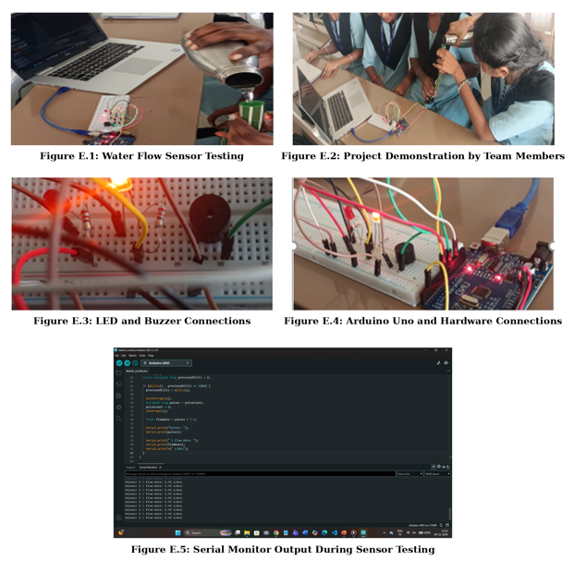

Recommended report formatting
Item | Suggested format
Paper size | A4
Font | Times New Roman
Body text | 12 pt
Chapter headings | 16 pt, bold
Section headings | 14 pt, bold
Line spacing | 1.5
Alignment | Justified body text
Margins | Left 1.5 inches; other margins 1 inch
Page numbering | Roman numerals for preliminary pages; Arabic numerals for chapters
Figures and tables | Numbered, titled, and referenced in the text
Length | Approximately 30–50 pages, depending on institutional requirements

Project title IoT-Based Smart Water Monitoring System for Leakage Detection and Prevention of Unauthorized Water Usage

